CELEBAL SUMMER INTERNSHIP
DevOps Project
Submitted by: Hemansh Sankhla
-----------------------------------------------------------------------------
- Problem Statement: Development on VM using Git and pushing code to azure repos
-----------------------------------------------------------------------------

PHASE 1: VM Setup & Prerequisites

- Created a Virtual Machine in Azure
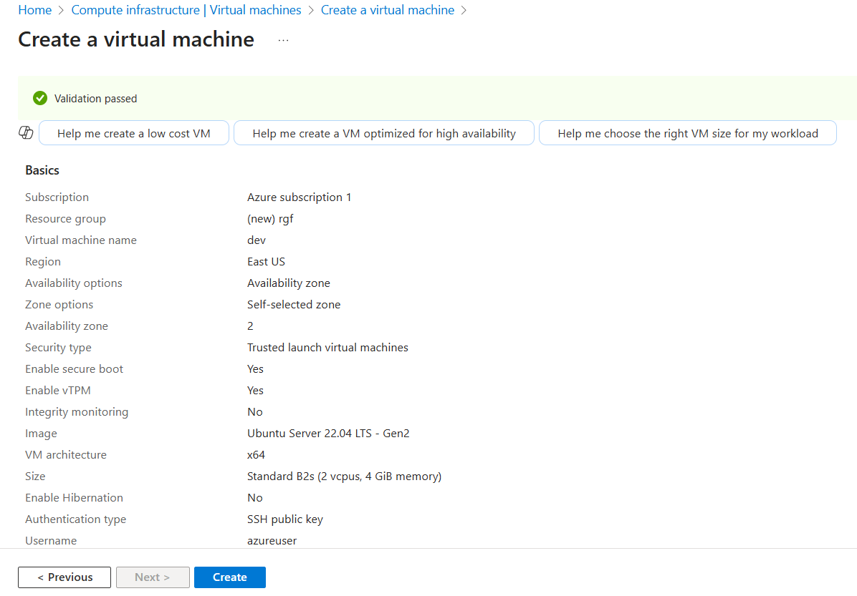

- Connected to the VM
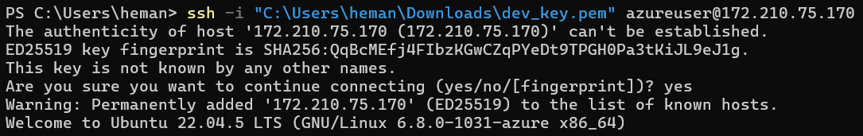

- Installed Git on VM
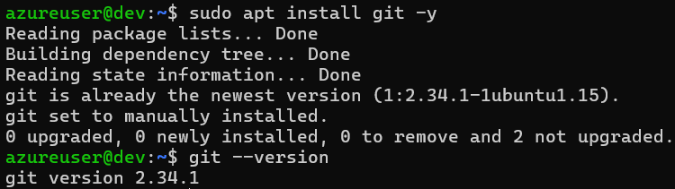

- Configured Git

- Installed tools on VM
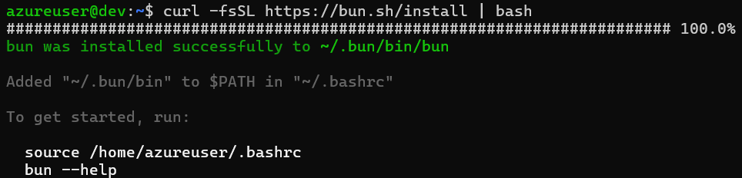
-----------------------------------------------------------------------------

PHASE 2: Azure Repos Setup

- Created Azure DevOps Project
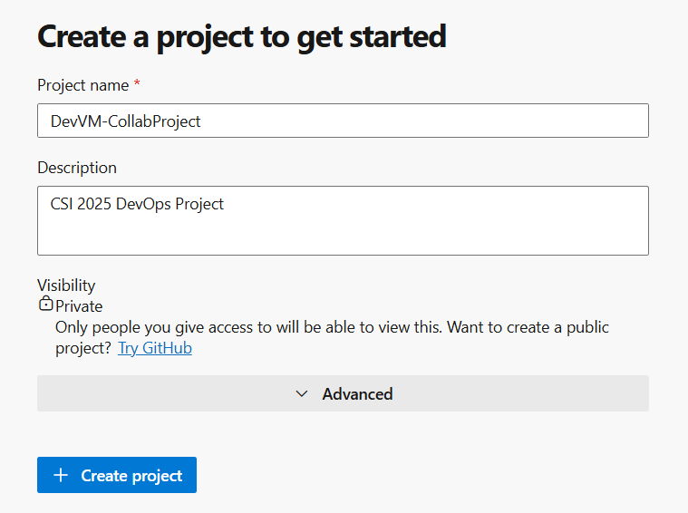
- Cloned repo on the VM
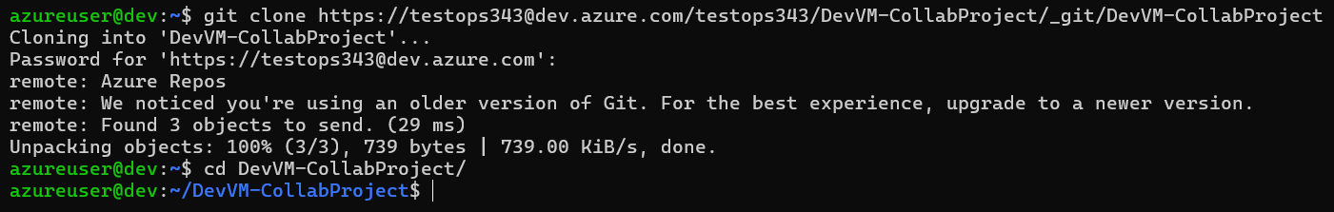
-----------------------------------------------------------------------------

PHASE 3: Adding Static Website

- Copied Static Website Files from local system

- Moved to repo directory
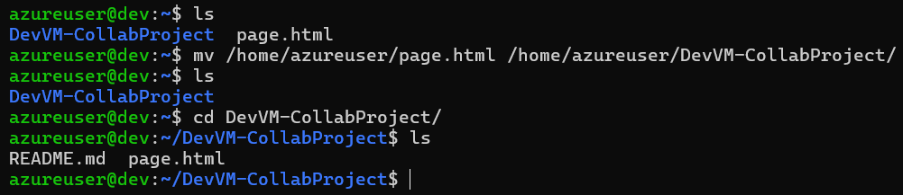
-----------------------------------------------------------------------------

Phase 4: Git Workflow on VM

- Stage, Commit and Push
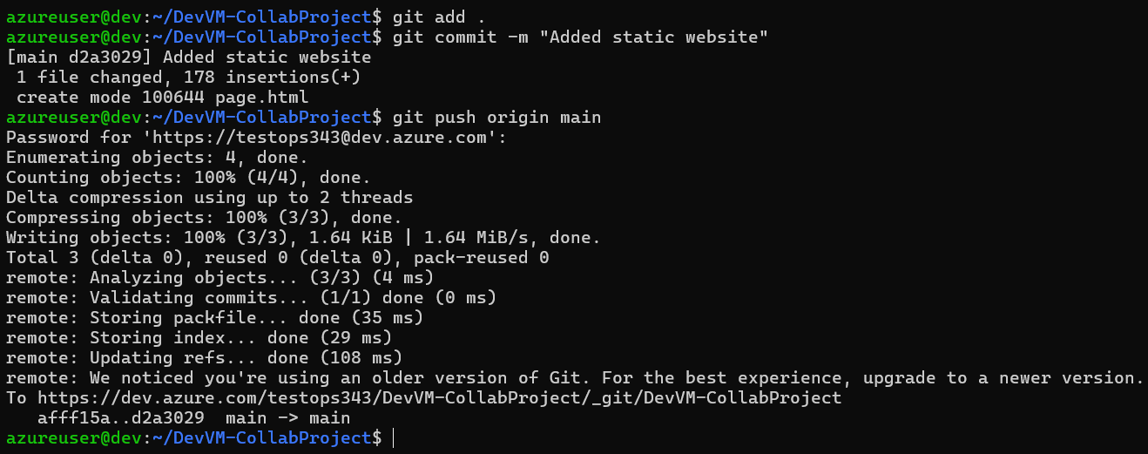
- File updated in Azure Repo
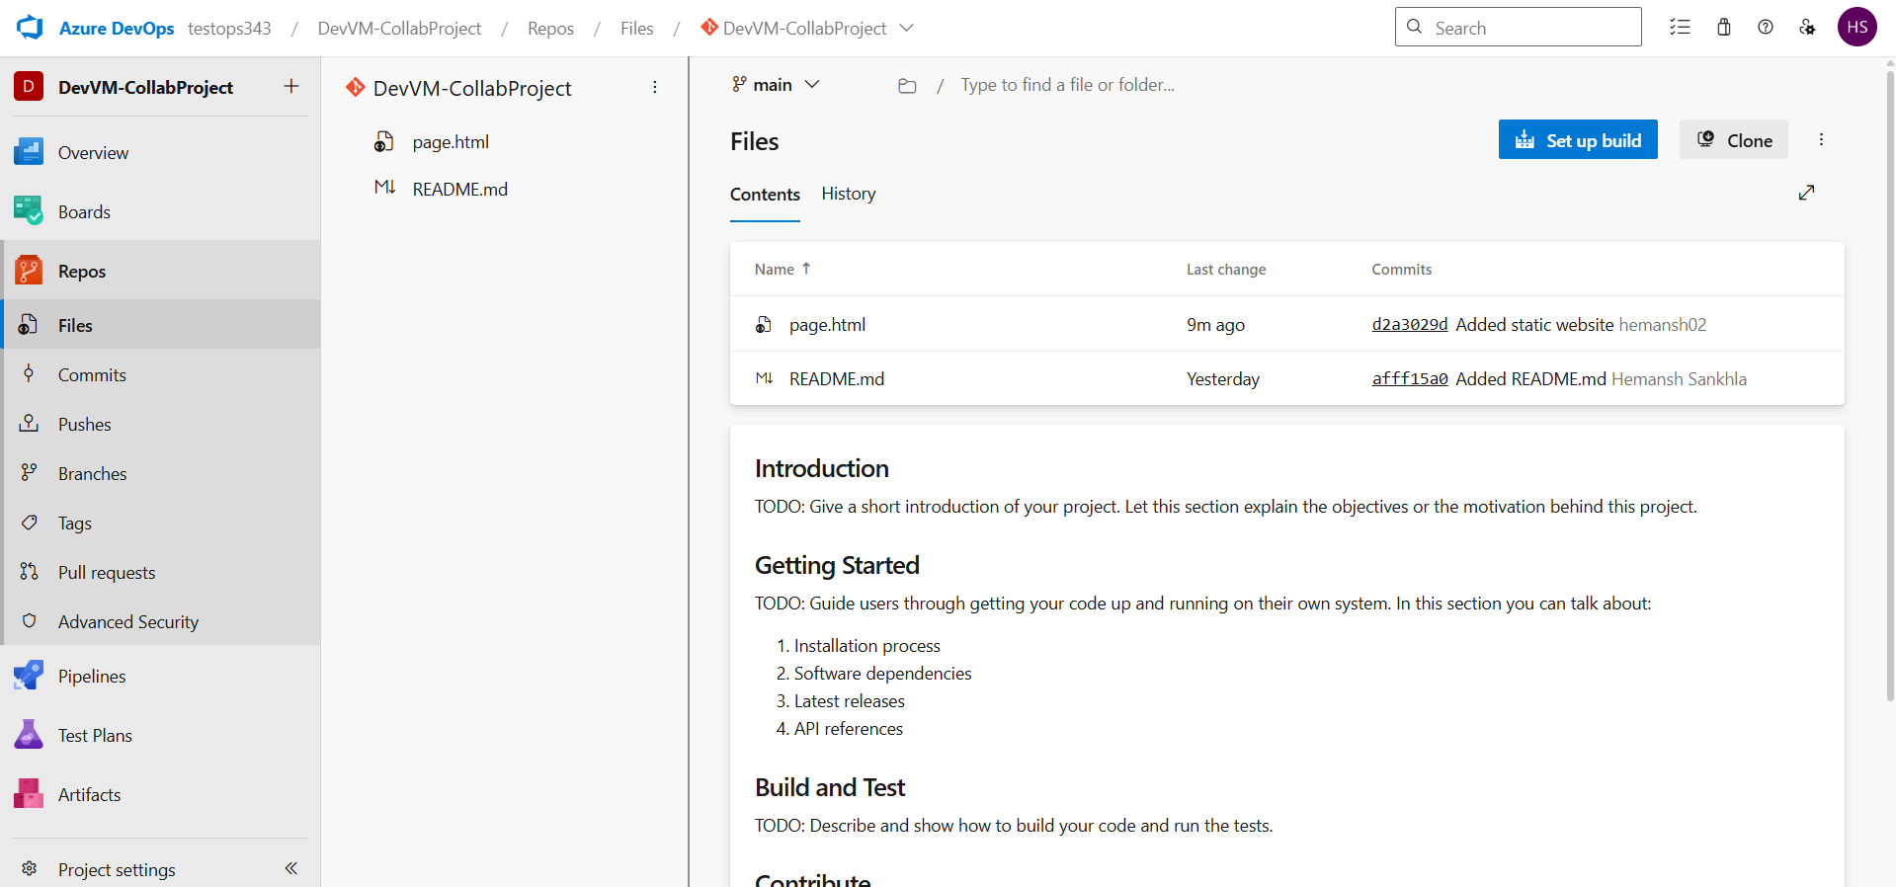
-----------------------------------------------------------------------------

Phase 5: CI/CD Pipeline

- Created Build Pipeline (CI)

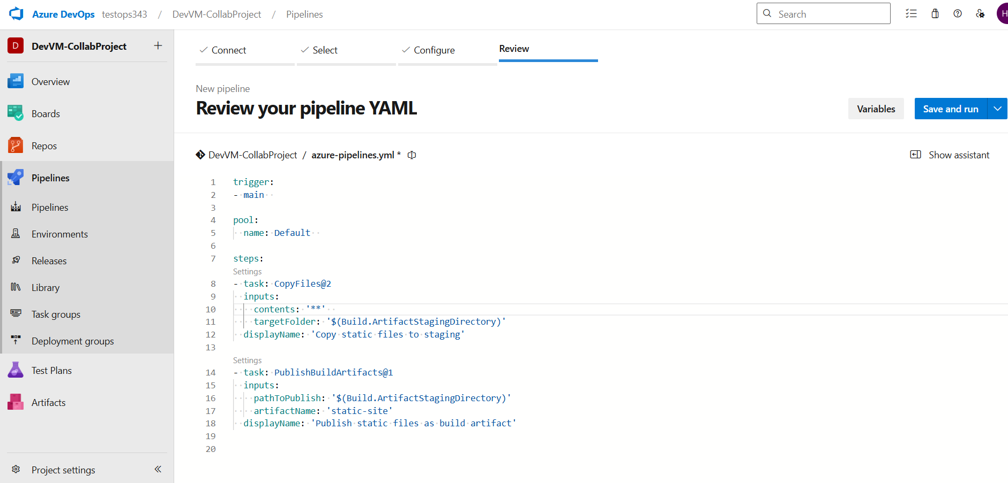

- Job is Successful
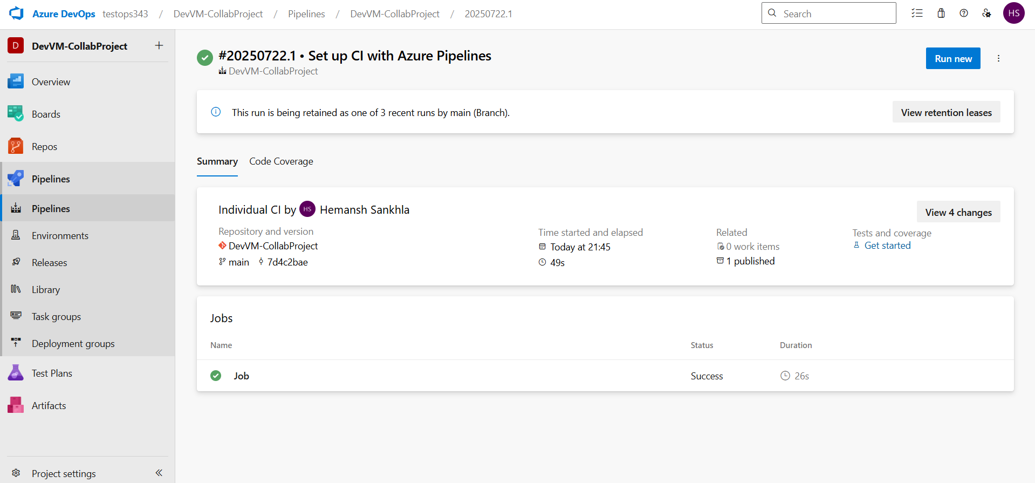

- Created Release Pipeline (CD)

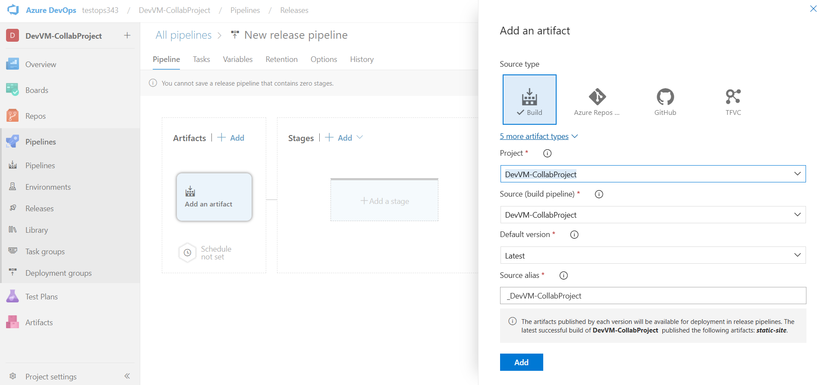
Added an Artifact

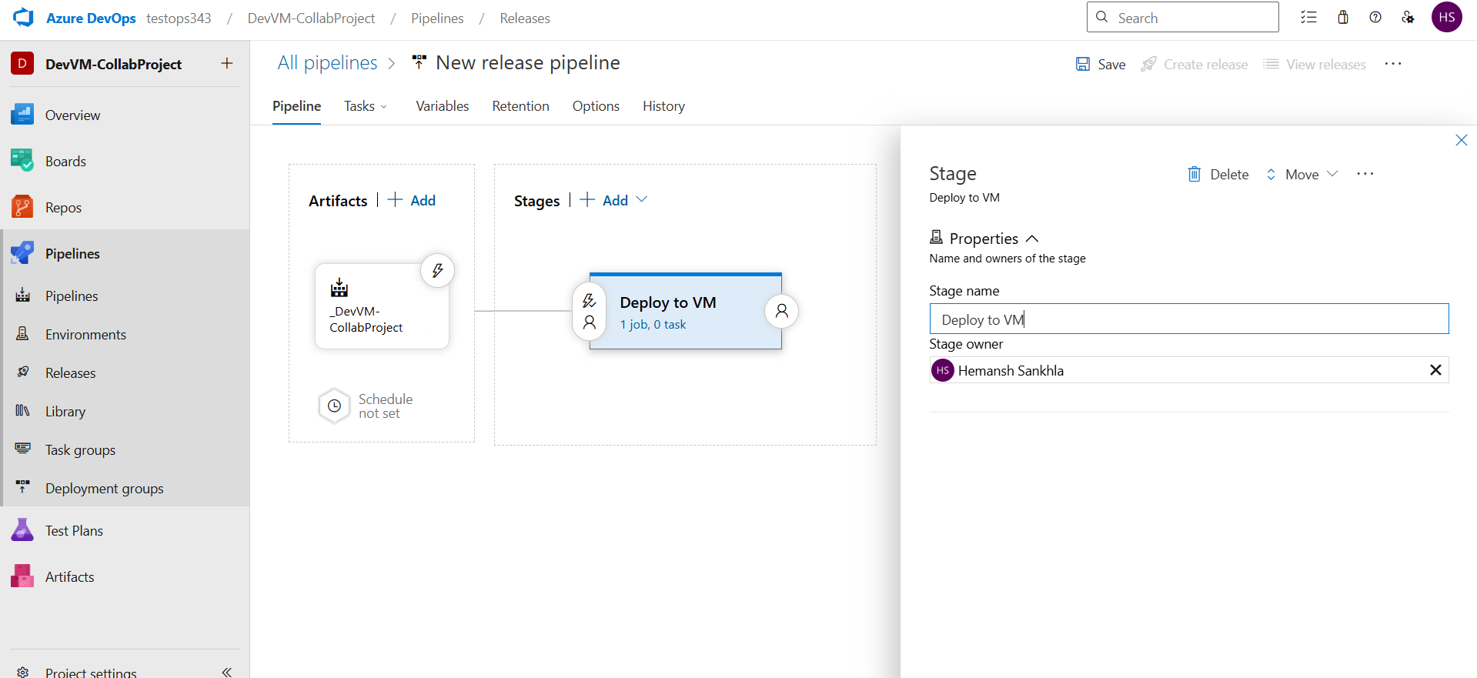
Added a Stage
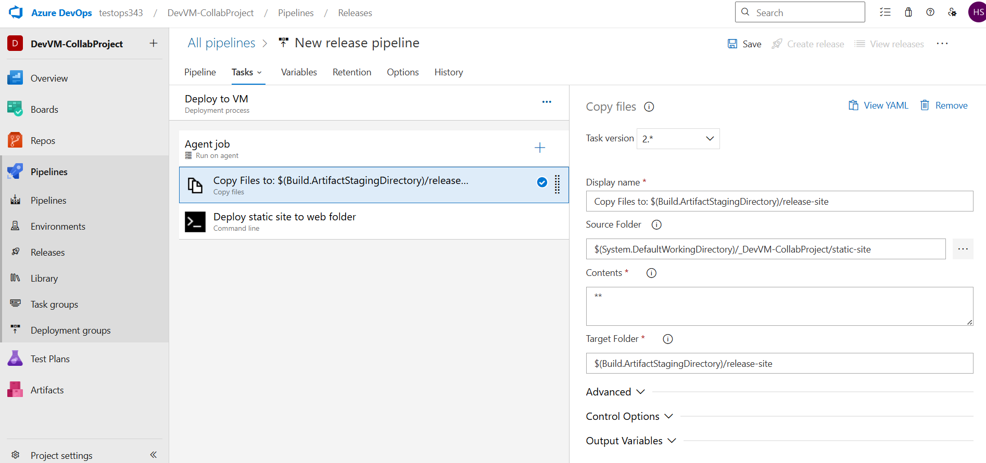
Added Deployment task

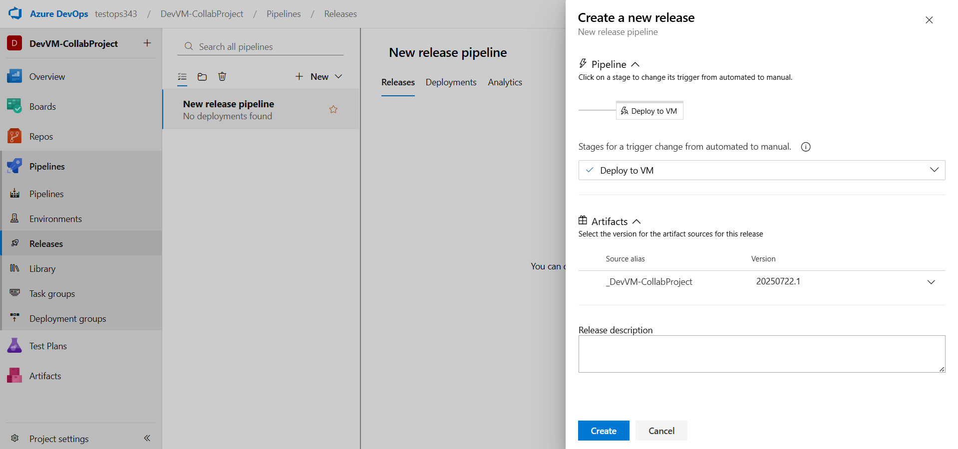
Finally created the Release

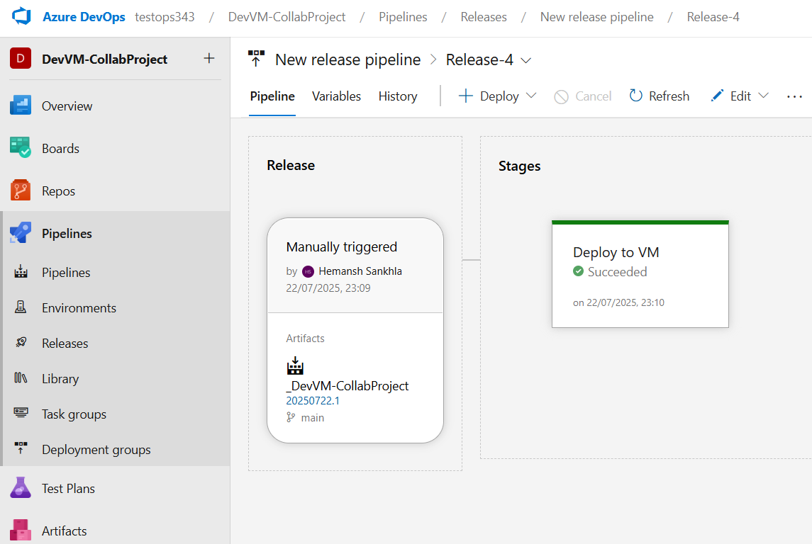
Deploy to VM successful
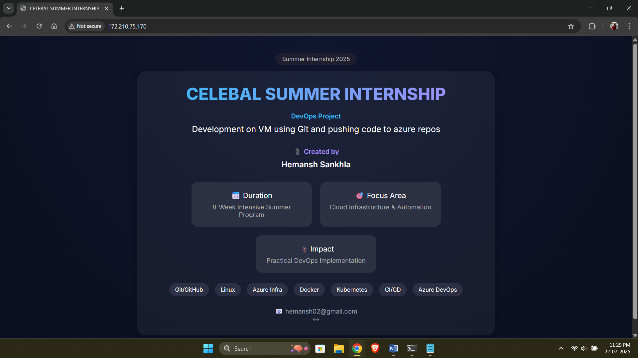
Successfully Deployed Static Website on Azure VM via Azure Repos and CI/CD
-----------------------------------------------------------------------------

THANK YOU!

